GAURAV PANJWANI 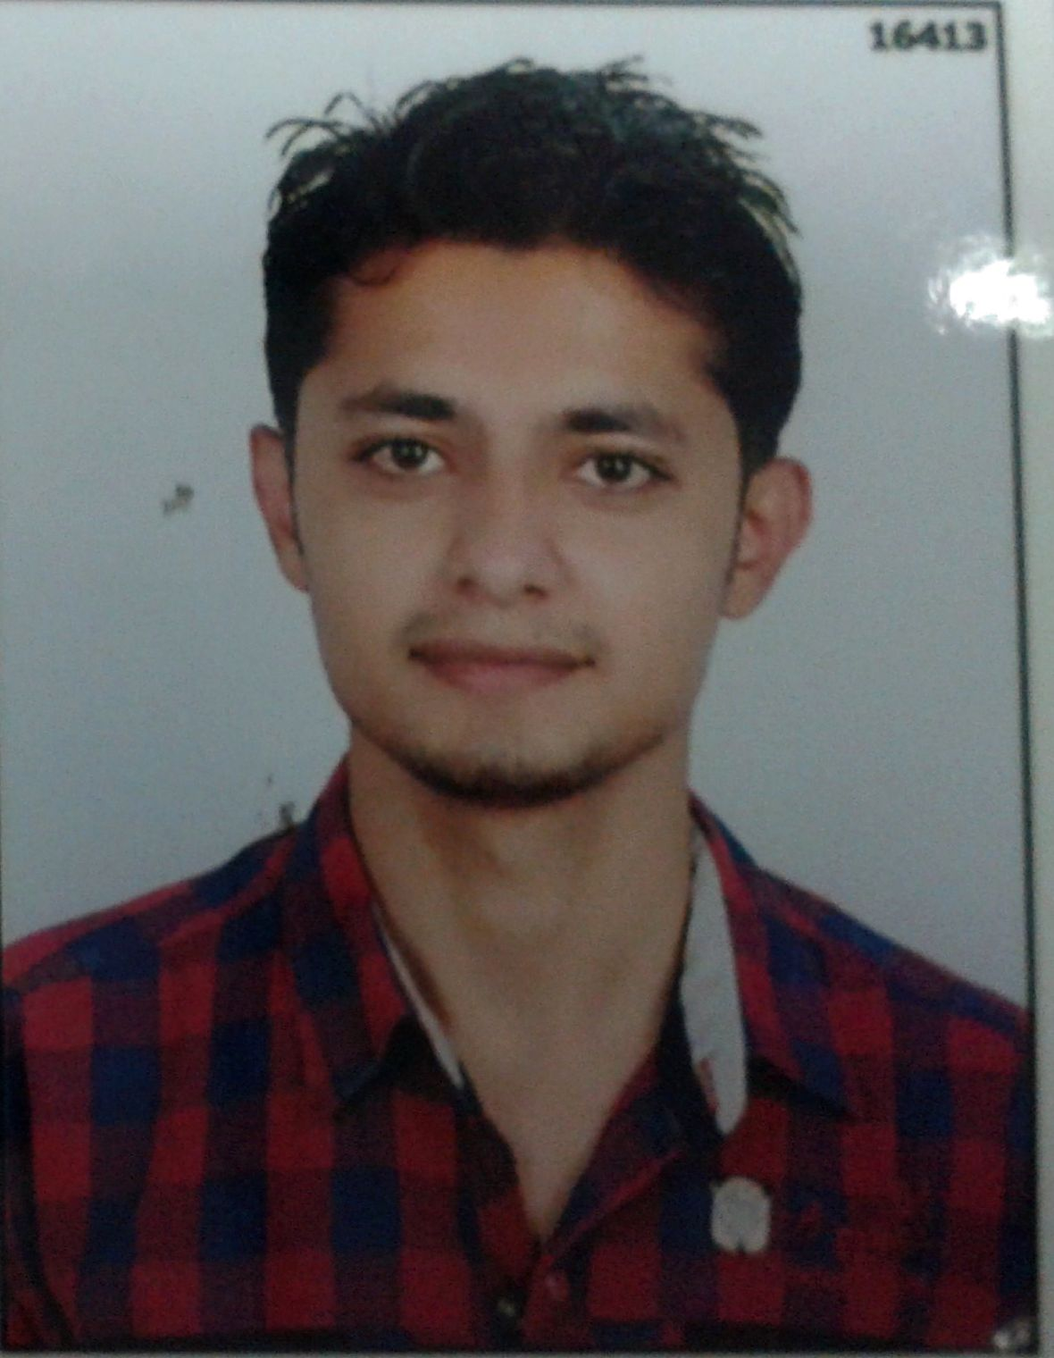
MALE, 25 Years
lgaurav29@gmail.com
Contact No: +91-7623832016
CAREER OBJECTIVE
To grow along with the organization considering organizational objective as my whole sole objective, to work in disciplinary manner with all my productive efforts, good skills to ensure good result for the organization and overall development of my knowledge for career aspect.

EDUCATION

B.TECH (Mech. Engg) | 2013 68 % | Maharishi Arvind College of Engineering and Technology, Kota , Rajasthan
Higher Secondary | 2009 76 % | Modern Se. Sec. School , CBSE Board
High School(10th) | 2007 80% | Modern Se. Sec. School , CBSE Board

WORK EXPERIENCE

- Worked in Pipavav Defense & Offshore Engineering Company Limited, Gujarat as Mechanical Engineer for 16 months.
  - Projects worked on:-
ESSAR’s Barge-DLB NAND GAURAV

- Vessel came to yard for dry docking repairs and also Load testing of the 800 Ton crane on board. Dry docking jobs done include Hull Blasting and Painting, Anchor chain routines and complete overhauling of all Ship side valves.
ONGC SAGAR SHAKTI RIG
Dry docking of Rig and carry out extensive repairs to Spud cans and joining Jack up leg chords.

ONGC SAGAR LAKSHMI RIG
- Job involves up-gradation of process / production equipment’s, Survey of entire hull and renewal of steel plating, Renewal of several pipeline system, Overhauling of existing machinery, Inspection and repairs of Spud cans / Jack up legs with brazers and refurbishment of entire Accommodation.

ONGC RIG SAGAR PRAGATHI
- Key scope involves conversion of Drilling unit to production facility.

ENTERPRISE RESOURCE PLANNING (IFS SOFTWARE)

PROJECTS / ASSIGNMENTS

- One month KSTPS (RVUNL) project.
- KSTPS: - Kota Super Thermal Power Station which has the capacity of generating 1240MW electricity. Under this project have learned about the boilers, controlling units, esp. unit, cooling towers, water treatment plant, coal handling plant, ash handling plant, and economizer.

EXTRA-CURRICULAM ACTIVITY
- Participation in seminar program on hydraulics machinery held in our College.
- Seminar program on “ESCALATORS” presented in MACET, KOTA.
- Final year project on “FOOT-STEP ELECTRICITY GENERATOR”

PERSONAL SKILLS
- Strong impression on others in a short span of time.
- Flexible and result-oriented attitude.
- Excellent analytical and troubleshooting skills.
TECHNICAL PROFICIENCY
Office tools : MS Office
Others : Internet, Auto Cad, Robotics.

Personal Details
Father’s Name : Mr. V. K. Panjwani
DOB : 29/10/1990
Gender : Male
Nationality : Indian
Marital Status : Single
Language : English, Hindi, Punjabi.
Address : Bungalow no.2, Devikrupa Rajni Smurti Soc., B/s. “AMA”, “IIM” Road,
Ahmedabad-15
DECLARATION
I confirm that the information provided by me is true to the best of my knowledge and belief.

Place : Kota
Date :
GAURAV PANJWANI

